**COMSATS University**

**Islamabad**



**Lab Report # 11**

**Real Time Embedded Systems**

**(EEE-446)**

|  |
| --- |
| **Control of AC Loads using Embedded Hardware.** |

**Submitted By:**

**Hassaan Ahmed (FA16-EEE-033)**

**Submitted To:**

**Dr. Ahsen Malik**

# Lab # 11

## Control of AC loads using embedded hardware.

### Objectives

* Learn how to control AC load using embedded system
* Discover the new components to control AC Load

### Tools

* Arduino
* Proteus ISIS

### In-Lab Task 1:

Design and implement an embedded system to turn ON/OFF the 220V AC light from a button interfaced with controller

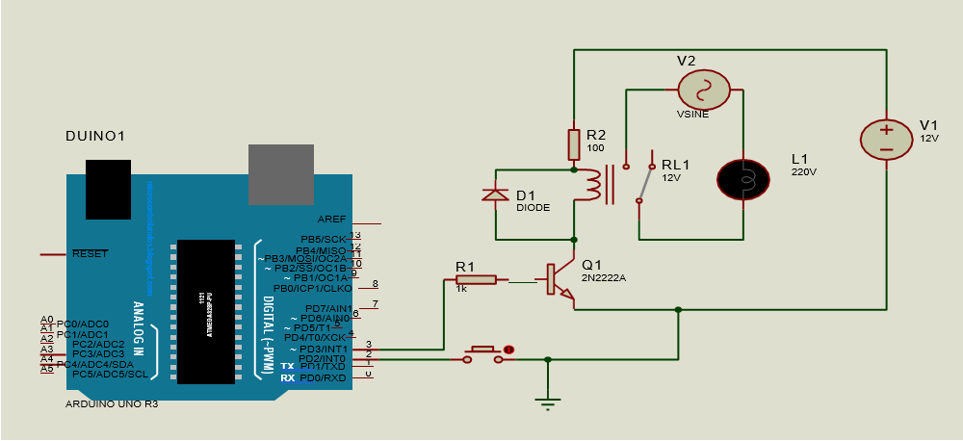

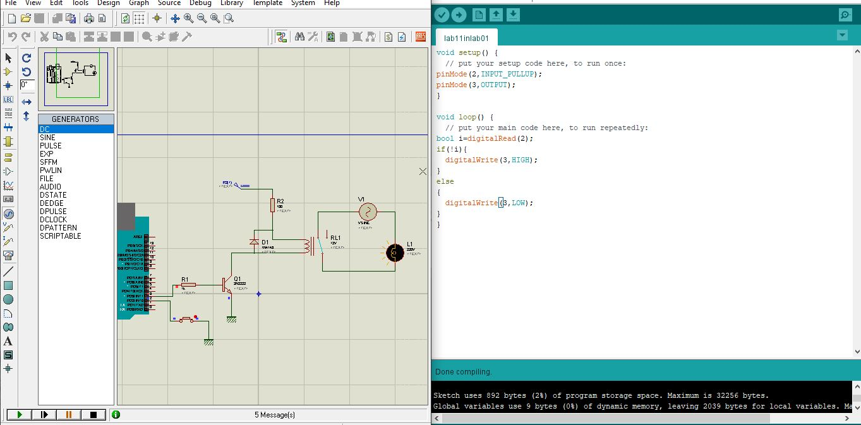

### In Lab Task 2:

Using the circuit used in the previous task, please add the opto-coupler at the optimum place and do the same task again to make our controller more secure.

## Proteus Schematic:

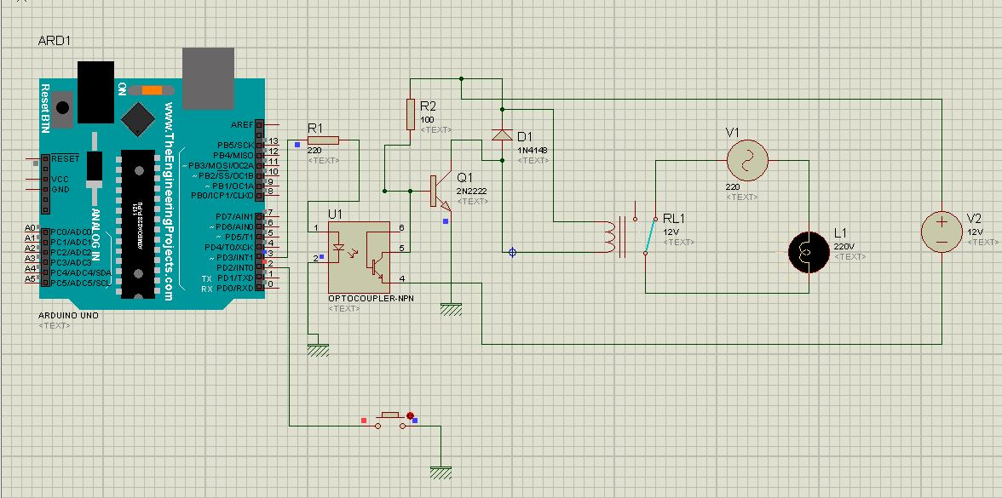

## Arduino IDE Code:

|  |
| --- |
|  |

# Conclusion:

|  |
| --- |
| In this lab, the control of AC loads with the utilization of embedded gadgets was considered. AC control switches, for example, SCR (TRIAC), optocoupler/optoisolator, relays and so forth were additionally utilized in blend with a microcontroller. Ordinary AC loads, for example, engines, bulbs, fans and so forth can computerized utilizing embedded frameworks.  The speed/power of fans/bulbs can likewise be constrained by AC controlling devices like TRIAC or a SCR. |

